**Objective Questions:**

1. What is the total number of attributes in the customer table?

Answer – The total number of attributes in the customer table -3 .

Column -3 and row -1000

1. Customer ID
2. Customer Age
3. Customer Gender

Before Aanlysis-3

After Analysis -3

This is table –

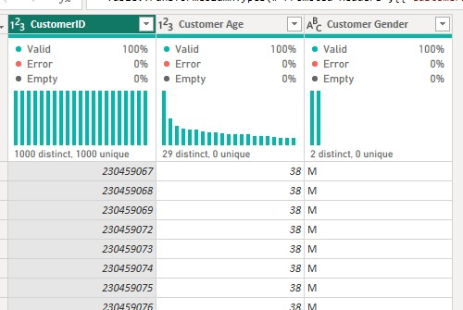

1. How will you get the “Customer’s” ages in the “Order” tables according to customer IDs?

Answer- Step. **1.Merge the Tables**:

* + In Power Query, use the **Merge Queries** function.
  + Select the “Order” table as the primary table and the “Customer” table as the related table.
  + Specify the **CustomerID** as the common field for merging

1. **Join Types**:
   * Choose an appropriate join typesuch as  **Left Outer Join**.
   * A **Left Outer Join** will include all records from the “Order” table and matching records from the “Customer” table.
2. **Select Relevant Columns**:
   * After merging, select the columns you need: **CustomerID** and **Customer Age**.
3. **Filter by Customer IDs**:
   * Apply a filter to include only the desired **Customer IDs**
4. **Result**:
   * I will get in Customer table their corresponding **ages**.

**Visualization**: We can create a visualization such as Donut chart to display the **Customer Age Product Categories**

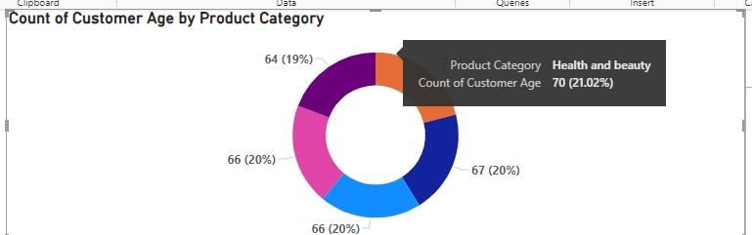

Analyzation: By analyzing this chart, you can identify which product categories are popular among different age groups.

For example, I find that age 70 tend to buy Health and beauty

1. In analyzing the dataset with Power BI, ensure data cleaning to address inconsistencies and missing values before further analysis.

Answer –

1. **Removed Null Columns**: In the Power Query Editor, I identified four columns that were entirely null and removed them dataset.
2. **Replaced Blank Values in ‘Reason’**: I found blank entries in the ‘Reason’ column, which you replaced with ‘Not Mention’ to indicate that no specific reason was provided.
3. **Missing Value** : I also discovered a blank value in the ‘Product’ column and filled it in with ‘Health and Beauty’.

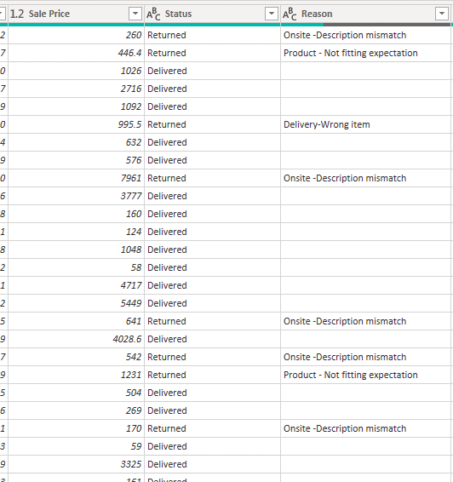

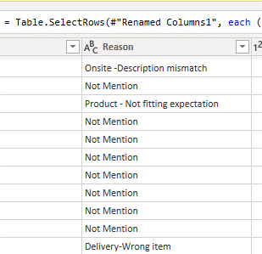

1. How can we calculate the total revenue generated by all the sales?

Answer- we can follow the below steps.

1. **Gross Revenue Calculation**: You started by calculating the **Gross Revenue**, which is the total sales amount before accounting for any returns. This is like adding up all the money you’ve made from sales, without considering any products that came back.

Here’s the formula you used:

**Gross Revenue = SUM (Orders [Sale Price])**

This measure adds up the **Sale Price** of all orders, giving you the initial total revenue.

1. **Returned Revenue Calculation**: Next, you focused on the money lost due to returned products. To find this, you created a measure called **Returned Revenue**. Think of this as counting all the money that had to be given back to customers when they returned items.

The formula looks like this:

**Returned Revenue = SUMX (FILTER (Orders, Orders [Status] = "Returned"), Orders [Sale Price])**

This measure filters your orders to only include those with a status of “Returned” and then sums up the **Sale Price** of these orders to get the total revenue lost due to returns.

1. **Total Net Revenue** : Finally, you calculated the **Total Revenue**. This is the money you actually get to keep after subtracting the returns from the gross revenue. It’s like your final profit.

Here’s how you did it:

**Total Revenue = [Gross Revenue] - [Returned Revenue]**

This measure takes the total money made from sales (**Gross Revenue**) and subtracts the money lost due to returns.

Visualization: We can create a visualization such as Card to display the totalRevenue.

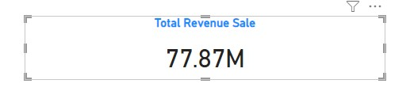

1. What is the total number of unique customers who made purchases each year? Is there any increase in the number over the years?

Answer :To Perform this task, we can follow the below steps.

Create calculated column: Create a calculated column named "Order Year". In order to extract the years from the order date we can use "YEAR function in DAX

Formula: Order Year = YEAR(Orders [OrderDate])

Create Measure: Now, we can create a Measure to count the number of unique customer per year. This DAX measure calculates the total number of unique customers per year by removing all filters except for the year Formula: unique customer per years = CALCULATE(DISTINCTCOUNT(Orders [CustomerID))

Create Measure: Now, we can create a Measure to count the number of unique customer per year. This DAX measure calculates the total number of unique customers per year by removing all filters except for the year

Formula: unique customer per years

CALCULATE(DISTINCTCOUNT(Orders [CustomerID). ALLEXCEPT [Orders Orders Order Year])

Visualization: We can create a visualization such as Line chart to display the total number of unique year who made purchase each year .

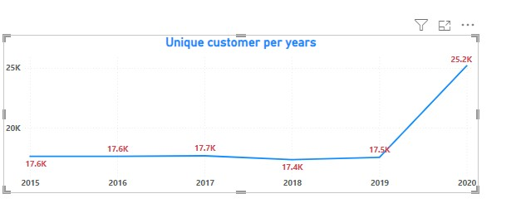

Analyzation: After analysing the chart, we can conclude that there is Increase of customer purchase every year .

1. How can we determine the total number of unique products available in the company?

Answer- To Perform this task, we can follow the below steps.

Create Measure: Now, we can create a Measure to count the number of unique Product . This DAX measure calculates the total number of unique Product

Formula: Unique Product = CALCULATE(DISTINCTCOUNT(Orders [Product])

Visualization: We can create a visualization such as card to display the total number of unique product.

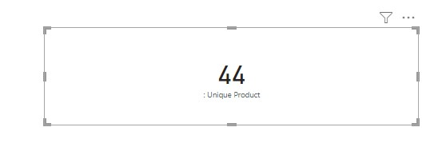

1. What is the average number of days it takes for products to be delivered, get the metric for only the delivered orders.

AnswerTo Perform this task, we can follow the below steps.

Create New column: Create a column named "Average Delivery ". In order to extract the orders date and Delivery from the order table we can use "Dateifffunction in DAX.

Formula:

Average Delivery = AVERAGEX(FILTER(Orders, Orders[Status] = "Delivered"),DATEDIFF(Orders[OrderDate], Orders[Delivery Date], DAY))

Visualization: We can create a visualization such as Card to display the Average delivery day-10

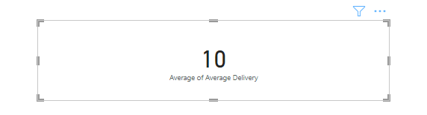

1. Which products, categories, and subcategories are the most popular?

Answer- **S“Top-Selling Product: Canon EOS 600D DSLR Camera”**

1. **Selected a Cluster Bar Chart**: You chose an appropriate visual to display the data, making it easy to compare the popularity of different products.
2. **Applied a Top 10 Filter**: You’ve smartly filtered the results to focus on the top 10 products, ensuring that the chart highlights the best performers.
   * + The bar graph displays the total revenue generated by several products .
     + Products listed include:
       - **Canon EOS 600D EF-S18MP CMOS DSLR Camera (Black)**
       - **Amazon Fire HD 8 Kids Tablet (32GB)**
       - **Samsung Galaxy A02 (16GB HDD)**
       - **Infinix Smart HD (2021) (32GB)**
       - **Samsung A3 Core DS SM-A013G (16GB HDD)**
       - **10.1” Business Tablet with MT6582 (32GB HDD)**
       - **6690-3 RJ Bluetooth Home Theater W/TF/FM Radio & Remote Control (Black)**
       - **Potluck Lunch Box (Brown)**
       - **8 Cubes Plastic Wardrobe (Blue/White)**
   * **Observations**:
     + **Canon EOS 600D DSLR Camera**:
       - This product has the highest total revenue, as indicated by its longest blue bar.
       - It consistently contributes significantly to overall revenue.
3. Visualization: We can create a visualization such as Bar Chart to display the Most Popular Product.

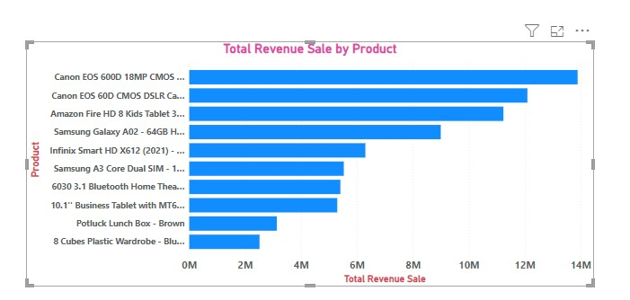

**Title: “Top-Selling Category: Phones and Tablets”**

**Selected a Cluster Bar Chart**: This visual format is excellent for comparing different products based on revenue

* 1. The bar graph displays the total revenue generated by several product categories .
  2. Categories listed include:
     1. **Phones and Tablets**
     2. **Electronics**
     3. **Fashion**
     4. **Health and Beauty**
     5. **Home and Office**
  3. Each category has a corresponding blue bar indicating the level of revenue generated.

**Observations**:

* 1. **Phones and Tablets**:
     1. This category has the longest bar, suggesting it has generated the most revenue.
     2. Consider investigating why this category is so popular. Are there specific products driving the revenue

.

**Conclusion**:

After analyzing the data with these steps, you found that products in the **Phone and Tablet** category are the most popular.

**Visualization:** We can create a visualization such as Bar Chart to displaythe Most Popular ProductCatergory.

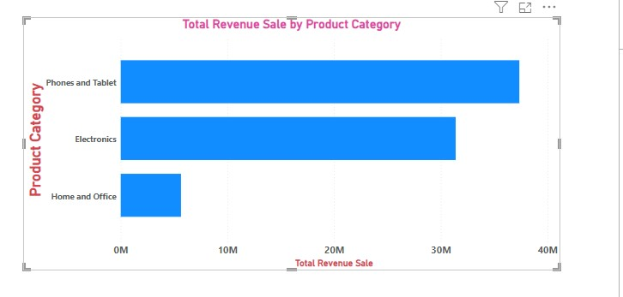

**“Top-Selling Product Category: Digital Cameras”**

**Chose a Cluster Bar Chart**: This visual helps to compare the sales performance of different products.

* + The bar graph displays the total revenue generated by several product sub-categories across .

Sub-categories listed include:

* + - **Digital Camera**
    - **Mobile phones**
    - **Tablets**
    - **Home Audio**
    - **Kitchen and dining**
    - **Medical supplies and Equipment**
    - **Girl’s fashion**
    - **Home and furniture**
    - **Vitamins / Dietary Supplements**
    - **Beauty and personal care**
  + Each sub-category has a corresponding blue bar indicating the level of revenue generated.

1. **Observations**:
   * **Tablets**:
     + The “Tablets” sub-category has significantly higher revenue compared to other sub-categories, as indicated by its longer bar.
     + It is the most popular sub-category in terms of revenue.

**Conclusion**:

After following these steps, your analysis revealed that the **Digital Cameras** subcategory is the most popular based on total revenue sales.

Visualization: We can create a visualization such as Bar Chart to display the Most Popular Product Category.

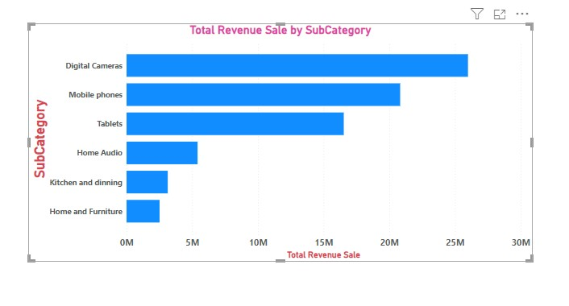

1. Which products have seen an increase or decrease in sales over the year?

Answer **:Line Chart-**

* + The line chart displays the total revenue generated by three different products from **2015 to 2020**.
  + Each product has its own colored line on the graph:
    - **Blue line**: Represents **Amazon Fire HD 8 Kids Tablet**.
    - **Yellow line**: Represents **Canon EOS 600D DSLR Camera**.
    - **Red line**: Represents **Canon EOS 6D MKII DSLR Camera**.

1. **Observations**:
   * **Canon EOS 600D DSLR Camera**:
     + The revenue for this product shows a steady increase from **2015 to 2020**
     + In **2020**, there is a significant spike in revenue, reaching approximately **$2.57 million**.
   * **Canon EOS 6D MKII DSLR Camera**:
     + The revenue for this camera shows a relatively stable trend with minor fluctuations.
     + There is no significant spike or drop during the observed years.
   * **Amazon Fire HD 8 Kids Tablet 32GB HDD - 2GB RAM - 8" Blue**
     + Similar to the**Amazon Fire HD 8 Kids** revenue remains relatively consistent.
     + There is no noticeable or decline.

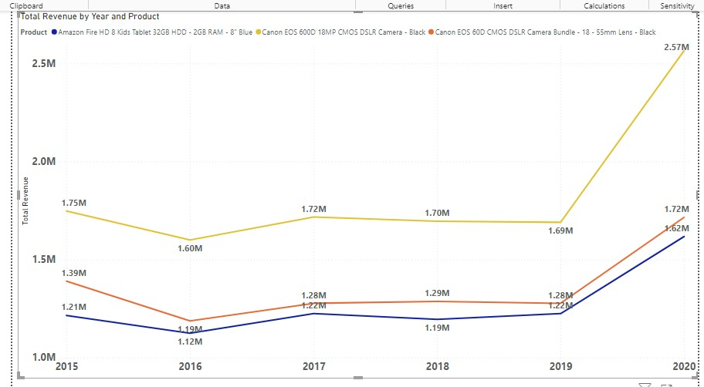

1. While modeling the data relationships, what will be the type of relationship between the customer ID of Orders and customer tables?

Answer - **“Data Relationships in Power BI: Many-to-One Relationship”**

1. **Introduction**:
   * Start by introducing the concept: “When modeling data relationships in Power BI, we encounter different types of connections.”
   * Focus on the relationship between the **customer ID** in the **Orders** table and the **customer** table.
2. **Many-to-One Relationship**:
   * Explain: “A **many-to-one** relationship signifies that multiple records in one table (Orders) correspond to a single record in another table (customer).”
   * Use an analogy: “Think of it like a customer placing several orders—each order links back to the same customer.”
3. **Example**:
   * Illustrate: “Suppose Customer A has placed three orders. In the Orders table, we’ll find three records with the same **customer ID** . However, in the Customer table, there’s only one record for Customer A.”
   * Visualize this relationship in your report.

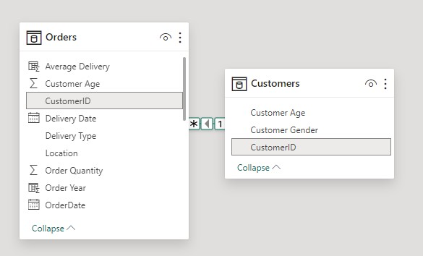

1. **Use Cases**:
   * Mention scenarios: “Many-to-one relationships are common when dealing with transactions, sales, or any situation where multiple events relate to a single entity.”

**Conclusion**

* Summarize: “In summary, the **many-to-one** relationship between Orders and Customer tables ensures accurate data representation.”

1. How have you handled the null values in the data?

Answer -**Null Values in Data**:

**Removed Null Columns**: In the Power Query Editor, I identified four columns that were entirely null and removed them dataset

* + Null values (missing data) can cause issues in analysis.
  + We need to handle them properly.

**Techniques to Handle Nulls**:

* + **Delete Rows**: Remove rows with null values .
  + **Impute Values**: Replace nulls with estimated values .
  + **Quality Control**: Regularly validate data formats.

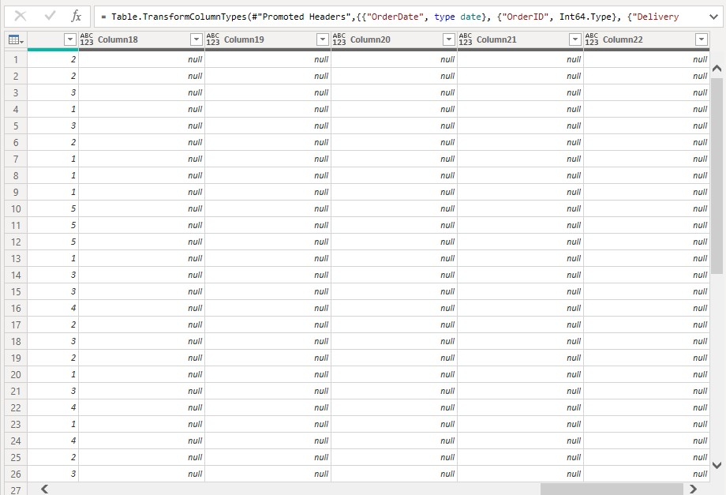

1. Were there any data format issues in the data, and if there were/are how you would handle them?

Answer- **Scenario: Sales Data with Format Issues**

* We have a dataset containing sales information for different products.
* The data includes:
  + Product names (text)
  + Sales quantities (numbers)
  + Order dates (dates in inconsistent formats)

**Data Format Issues:**

1. **Inconsistent Date Formats**:
   * Some order dates are in “MM/DD/YYYY” format, while others are in “YYYY-MM-DD” format.
2. **Handling Techniques**:
   * We’ll standardize the date format to “YYYY-MM-DD” for consistency.

**Result:**

* We’ve standardized the date format, making it easier for analysis.

1. When we add a column in Power Query what’s the code that comes in M language in the formula bar? What do you know about M-query?

Answer -**“Adding Custom Columns in Power Query using M Language”**

1. **Introduction**:
   * Start by introducing the topic: “In Power Query, we can enhance our data transformations by adding custom columns.”
   * Mention that we achieve this using the **M language**.
2. **Custom Column Creation**:
   * Explain the process: “When creating a custom column, we define a new column based on existing
3. **Example: Adding a addcolumn Year** 
   * Illustrate: “Suppose we want to extract the year from a Order date column.”
   * Show the M code: "We use the Table.AddColumn Year function with the following parameters:
     + table: The existing table.
     + newColumnName: The name of the Add column year .
     + columnGenerator: A function that computes the values for the new column (e.g., extracting the year from a date column).
4. **Sample M Code**:

**Add column Year =**

Table.RenameColumns(#"Added Custom",{{"Custom Year", "Add Column Year"}})

1. **Benefits of M-query**:
   * Discuss its advantages: “M-query offers powerful data transformation capabilities.”
   * Highlight flexibility: “We can handle complex scenarios, merge data, and create custom logic.”
2. **Conclusion**:
   * Summarize: “In summary, using M language, we can add custom columns efficiently.”

**Subjective Question:**

1. Explain the revenue breakdown by year and by-product. Evaluate how different products contribute to annual revenue and come up with suggestions to increase the sales of the low-selling items.

Answer- Revenue Breakdown by year -in year 2020 highest revenue .-25,65,013.

1. **Identify High-Revenue Products**:
   * Based on the graph, find the products that correspond to the highest points on the line Product Name -Canon EOS 600D 18MP CMOS DSLR Camera - Black
   * These are the top contributors to annual revenue.

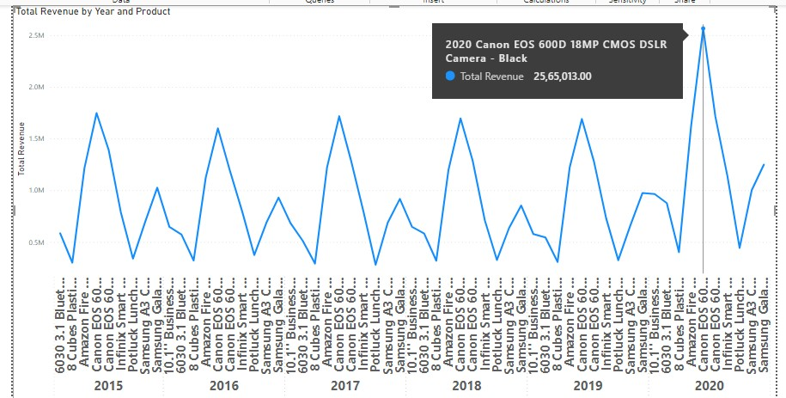

1. **Consider Impact**:
   * High-revenue product-Canon EOS 600D 18MP CMOS DSLR Camera - Black significantly impact overall annual revenue.
   * They may represent popular items.

**The sales of the low-selling item**

1. **Identify Low-Selling Products**:- Year 2017
   * Look for products with minimal revenue.- Total Revenue – 2,81,119.
   * These are the item that need attention.

Potluck Lunch Box - Brown

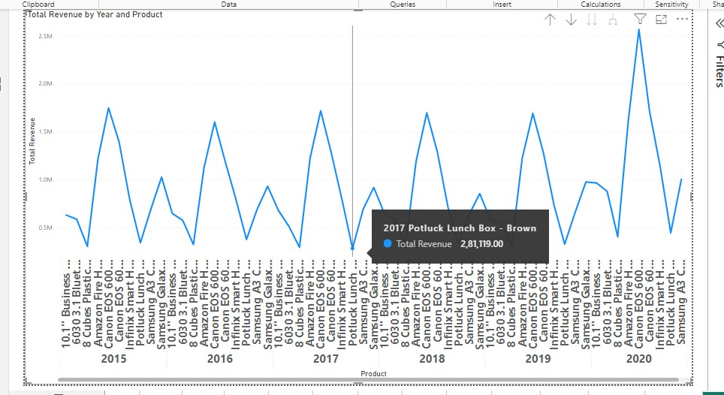

1. **Promotions and Discounts**:
   * Offer targeted promotions or discounts for low-selling item.
   * Consider bundling them with popular product.
2. **Market Research**:
   * Understand why certain products are not selling well.
   * Is it due to low demand, pricing, or other factors?
3. How many products were returned? Use a DAX function to get this metric. Examine the possible reasons for returns and consider how this metric could indicate improvements in product descriptions or quality control.

Answer -**Create a New Measure for Returns**:

* Use the DAX formula to create a measure that counts the number of returns
* Returned Products = COUNTROWS(FILTER(Orders,Orders[Status] = "Returned")

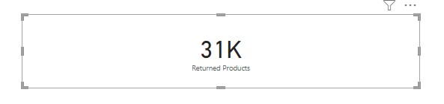

1. **Identify High-Return Sub-Categories**: ‘Medical supplies and Equipment’ has a significantly higher total than other sub-categories, this would be an area to focus on.
2. **Analyze Reasons for Returns**: .‘Quality Defective’ is a frequent reason, this indicates a potential issue with product quality in that sub-category
   * + **Quality Control**: there are quality issues leading to returns
     + Defective products- 576
     + Not fitting expectation-535

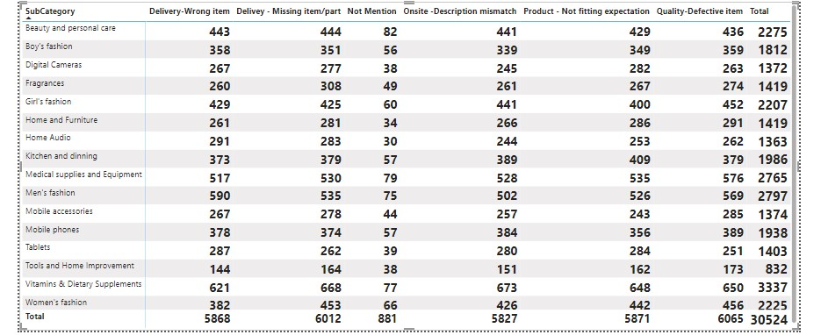

1. Whenever a customer goes to Amazon, they’ll filter the most rated products to buy the better category. Can you verify this using any visualization or table that the ratings of products impact their sales value?

Answer – Now I create line chart x-axis on average Rating and y-axis on Total Revenue and legend -product

We analyse and cloud see that there is no any trend where high rated product are selling most as compare to rated product.

Some low rated product are also the top selling.

I marked the red product with low rating but high sale.

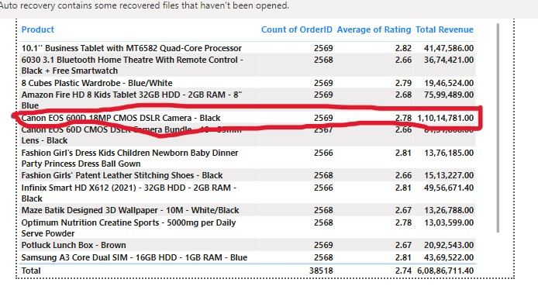

1. Investigate how revenue distribution varies across different locations. Explore which geographical areas contribute most to sales and consider the strategic implications for regional marketing and distribution efforts. How might location-based trends inform the company's market segmentation and resource allocation approach?

Answer- **Map Chart Analysis**:

* + The map chart displays various locations, primarily in Africa.
  + Larger bubble sizes indicate higher total revenue generated from specific regions.
  + Key regions contributing significantly to revenue include:
    - **Volta**
    - **Upper East**
    - **Upper West**
    - **Greater Accra**
    - **Ashanti**
    - **Weija**
    - **Eastern**
    - **Savannah**
    - **Western**
    - **Bono**
    - **North East**
  + These areas should be the primary focus for marketing and distribution efforts due to their revenue contribution.

**Strategic Implications**:

* + **Resource Allocation**:
    - Allocate marketing budgets and resources strategically based on revenue from high-performing regions.
    - Invest more in these areas to maximize returns.

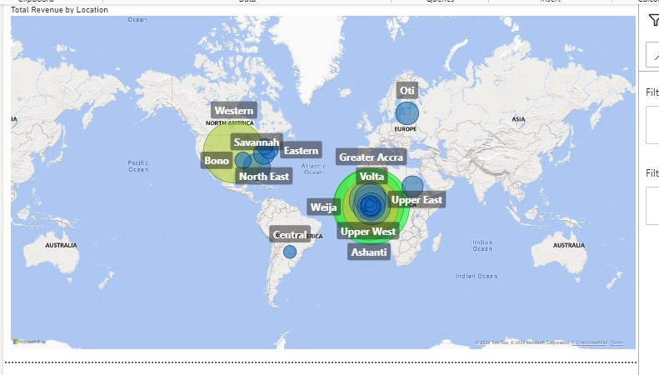

1. Determine which month could benefit from enhanced promotional offers to boost sales. Can you suggest some targeted marketing strategies here?

ANSWER- **Create a Measure for Current Month Sales**

 DAX formula:

Current Month Sales = SUM('Order'[Sale Price ])

**Create a Measure for Previous Year’s Same Month Sales**

Previous Year's Same Month Sales = CALCULATE (SUM ('Orders'[SalePrice] SAMEPERIODLASTYEAR('Orders'[OrderDate].[Date]))

**Create a Table**:

Now, create a new table that includes the following columns:

**Year**: Extract the year from the “Date” column.

**Month**: Extract the month from the “Date” column.

**Total Sales**: Use the “Current Month Sales” measure.

**Previous Year’s Sales**: Use the “Previous Year’s Same Month Sales” measure

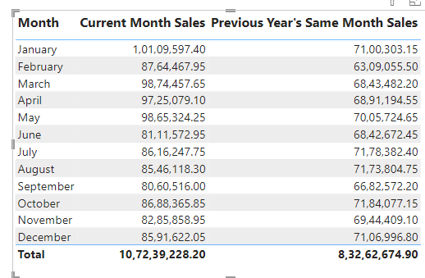

**Identifying the Month**:

* + Based on the data, **September** stands out:
    - Current Month Sales (September): 80,60,516.00
    - Previous Year’s Same Month Sales (September): 66,82,572.20
    - Difference: Current Month Sales - Previous Year’s Same Month Sales = 13,77,943.80 (positive growth)

**Targeted Marketing Strategies for September**:

* + To boost sales in September, consider the following strategies:
    - **Flash Sales and Limited-Time Offer**
    - **Email Campaigns**
    - **Social Media Engagement**:

1. Identify which products may require increased marketing efforts. Which items have high prices yet underperform in sales?

Answer- **Create a Measure for Current Month Sales**

 DAX formula:

Total Sales = SUM('Order'[Sale Price ])

**Create a Measure Total Count Order**

DAX formula:

Total count order = SUM('Order'[order Id ])

**Create a Measure Total unit Order**

DAX formula:

Total Unit Price = SUM('Order'[Unit price ])

**Create a Table**:- Product ,Total sale ,Total unit Price , Total count order

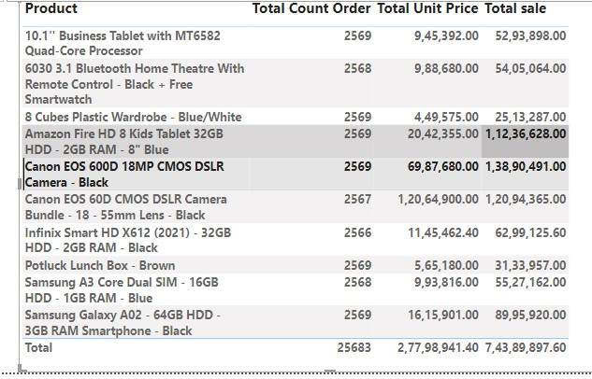

**Products with High Prices but Underperforming in Sales**:

* + To find these, we’ll look at the Total Sale relative to the total unit price. If the Total Sale is significantly lower than expected based on the high unit price, it indicates underperformance.
  + From the data, we can see that the following products fall into this category:
    - **Canon EOS 600D 18MP CMOS DSLR Camera - Black**: Despite its high total unit price, the total sales revenue is not proportionate.
    - **Canon EOS 60D CMOS DSLR Camera Bundle - 18-55mm Lens - Black**: Similar to the previous camera, it has a high total unit price but relatively low total sales.
  + These items may benefit from increased marketing efforts to boost sales.

1. Assess which products should have discounts. How can targeted incentives drive sales and customer loyalty for specific products?

Answer- I take table chart – Product , Average Unit Price , Average order Quantity , Total revenue-

We can cannon E60D cmosDslr Camera Bundle is unit price high and order quantity only one we can consider this product to give the discount .

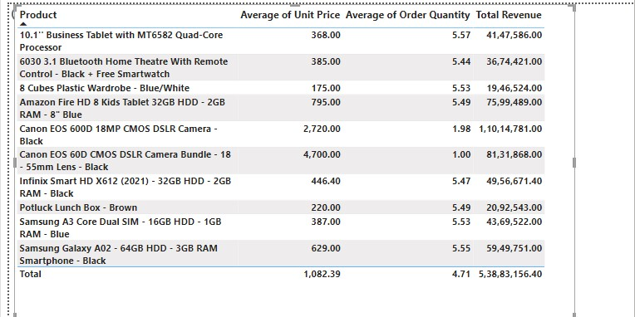

**Average Unit Price vs. Average Order Quantity**:

* + Look for products with a high average unit price but relatively low average order quantity.
  + These products may benefit from targeted incentives (such as discounts) to encourage more purchases.

**Total Revenue**:

* + Consider the total revenue generated by each product.
  + Products with substantial revenue contribute significantly to overall sales.
  + Focus on products that contribute a substantial portion of the total revenue.

**Customer Loyalty**:

* + Identify products that resonate well with existing customers.
  + Offer loyalty rewards or discounts to repeat buyers of specific products.

1. Come up with a loyalty program to benefit the company’s customers. From the available lot of customers come up with strategies to bucket them and provide benefits under different loyalty programs.

Answer-

**Anniversary/Birthday Rewards for Origin Program**

**Strategy**: Recognize and reward customers on their anniversaries with the company or their birthdays.

**Gaming Loyalty Program**

**Strategy**: Introduce gamification elements to engage customers and encourage repeat purchases.

**VIP Program**

**Strategy**: Identify high-value customers who consistently make significant purchases.

**Point-Based Loyalty Program**:

* + **Strategy**: Award points to customers for each purchase.
  + Higher-value items earn more points.
  + Customers can redeem points for discounts, free products, or other rewards.

**Frequency-Based Loyalty Program**:

* + **Strategy**: Segment customers based on their shopping frequency.
  + Frequent shoppers receive exclusive benefits.

**Referral Program**:

* + **Strategy**: Reward loyal customers who refer friends or family members.
  + When the referred individuals make purchases, the referrer receives benefits.

1. Using the DAX functions Calculate and a row iteration DAX function calculate the total sales for the Product Category “Fashion” and delivery type “Shipped from Abroad”. What are the other types of DAX functions you have used in the project?

Answer- The total sales for the Product Category “Fashion” and delivery type “Shipped from Abroad – 4.14M

Create calculated column: Create a calculated Measure named "Total Fashion “The total sales for the Product Category “Fashion” and delivery type “Shipped from Abroad.

Formula: Total Fashion

Total Fashion = CALCULATE(SUM('Orders'[Sale Price]), 'Orders'[Product Category] = "Fashion", 'Orders'[Delivery Type] = "Shipped from Abroad")

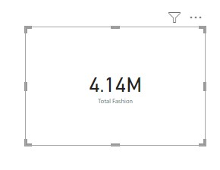

**Other Types of DAX Functions**:

* Besides CALCULATE, there are several other useful DAX functions you might have used in your project. Here are some common ones:
  + **SUMX**: Similar to SUM, but allows you to perform calculations on a table or column.
  + **AVERAGE**: Calculates the average of a numeric column.
  + **COUNT**: Counts the number of rows in a table or column.
  + **MIN** and **MAX**: Find the minimum and maximum values in a column.
  + **FILTER**: Applies a filter to a table or expression.
  + **ALL**: Removes filters from a table or column.

1. Wait Times Correlated with Demographics and Care: Explore how average wait times vary across different product categories to optimize scheduling and staffing.

Answer -**Calculate Average Wait Time** :

* For each interaction, calculate the AWT using the formula: Average Wait Time = Total Wait Time / Number of Customers Served.

**Group by Product Category**:

* Group the data by **Product Category**.
* Calculate the average Wait Time for each product category:
  + Observe patterns:
    - Health and beauty has the highest .
    - Electronics and Home Office has the lowest .
    - Fashion and Phones and Tablet fall in between.

**Optimize Scheduling and Staffing**:

* + Allocate more customer service representatives during peak times for high-demand product categories .
  + Adjust staffing levels based on historical wait time data.
  + Cross-train staff to handle multiple product categories efficiently.

**Monitor and Iterate**:

* + Continuously monitor Average wait Time .
  + Adjust staffing as needed.
  + Review the impact of changes on wait times and customer satisfaction.

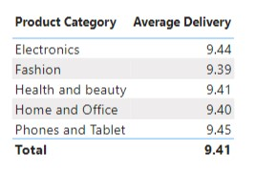

1. Explore if there is any relationship between the Delivery type and waiting time between ordering and receiving an item.

Answer- The table chart contains information on average delivery days for different combinations of **product categories** and **delivery types**.

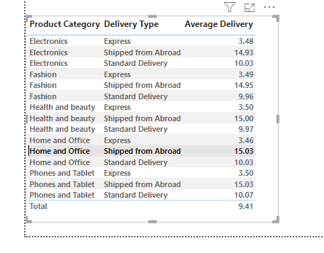

Here are some key observations:

* + **Electronics**:
    - Express deliveries have the shortest average delivery time (approximately 3.48 days).
    - Items shipped from abroad take the longest (around 14.93 days).
    - Standard delivery falls in between (about 10.07 days).
  + **Fashion**:
    - Similar to electronics, express deliveries are the quickest (around 3.49 days).
    - Shipped-from-abroad items have the longest average delivery time (approximately 14.95 days).
    - Standard delivery takes about 9.96 days.
  + **Health and Beauty**:
    - Express deliveries again show the shortest average time (around 3.50 days).
    - Shipped-from-abroad items take the longest (approximately 15.00 days).
    - Standard delivery averages around 9.97 days.
  + **Home and Office**:
    - Express deliveries remain consistent (around 3.46 days).
    - Shipped-from-abroad items have the longest average delivery time (about 15.03 days).
    - Standard delivery is approximately 10.03 days.
  + **Phones and Tablet**:
    - Express deliveries are the quickest (around 3.50 days).
    - Shipped-from-abroad items take the longest (approximately 15.03 days).
    - Standard delivery averages around 10.07 days.

1. **Observations and Insights**:
   * Express deliveries consistently have the shortest waiting time.
   * Items shipped from abroad generally have longer waiting times.
   * Standard delivery falls in between, balancing speed and cost.
   * Consider optimizing processes for shipped-from-abroad items to reduce waiting time.

### Conclusion:

The data suggests a clear relationship between delivery type and waiting time. Companies can use this insight to optimize their delivery processes, enhance customer satisfaction, and improve overall efficiency.

1. Is there any relationship between shipping charges and product type?

Answer-Shipping Charges by Product Category

the Table shows the average shipping fee for each product category. You can see that **Health and beauty**,has the highest average shipping fee, followed by **Fashion**  and  **Phones and Tablet** is same shipping fee.

**Observations**:

* + Look for any patterns or trends in the data.
  + Are certain product categories consistently associated with higher or lower shipping fees?

**Observations**

* + Health and beauty products tend to have higher shipping fees.
  + Fashionand Phones and Tabletproducts have moderate shipping fees.
  + Home and Office products have relatively lower shipping fees.

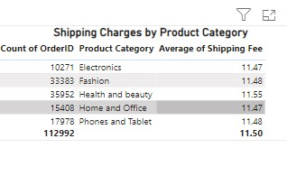

1. Come up with strategies to decrease the low rating orders after analyzing different factors like waiting time, shipping type, unit price, etc.

Answer-Answer- The table chart contains information on **average delivery product categories ,unit price and delivery types.**

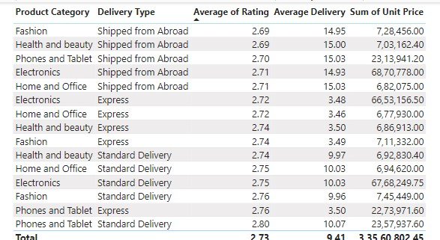

1. **Analyze the Data**:
   * **Rating Distribution**: Start by examining the distribution of ratings. Identify the proportion of low ratingscompared to higher ratings.
2. **Identify Key Factors**:
   * **Waiting Time**: Longer waiting times can lead to dissatisfaction. Analyze average delivery times-15day for low-rated orders.-2.69
   * **Shipping Type**: Compare ratings for different shipping types shipped from abroad Are certain types consistently associated with low ratings-2.69
3. **Strategies to Decrease Low Ratings**:
   * **Optimize Delivery Time**:
     + **Faster Shipping**: Consider offering faster shipping options, especially for high-value orders.
     + **Realistic Delivery Estimates**: Set accurate delivery time expectations during checkout.
     + **Track and Communicate**: Provide order tracking and timely updates to manage customer expectations.
   * **Improve Product Quality and Descriptions**:
     + **Product Descriptions**: Ensure accurate and detailed product descriptions to avoid mismatches.
     + **Quality Control**: Monitor product quality and address any issues promptly.
4. Using the time intelligence DAX function, create a table to compare each month’s sales with the previous year’s same month’s total sales. So there will be four columns in the output year, month, total sales, previous_years_sales.

Answer- **Create a Measure for Current Month Sales**

 DAX formula:

Current Month Sales = SUM('Order'[Sale Price ])

**Create a Measure for Previous Year’s Same Month Sales**

Previous Year's Same Month Sales = CALCULATE (SUM ('Orders'[SalePrice] SAMEPERIODLASTYEAR('Orders'[OrderDate].[Date])

)

**Create a Table**:

Now, create a new table that includes the following columns:

**Year**: Extract the year from the “Date” column.

**Month**: Extract the month from the “Date” column.

**Total Sales**: Use the “Current Month Sales” measure.

**Previous Year’s Sales**: Use the “Previous Year’s Same Month Sales” measure.

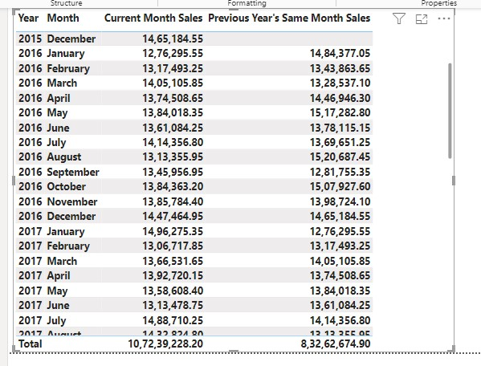

* The table provides a month-wise comparison of sales data between the current year and the previous year.
* For example, in January 2016, the current month sales were $12,76,295.55, and the previous year’s same month sales were $14,84,377.05.

1. What do you understand by PowerBI gateway? What are its use cases?

Answer-**Power BI Gateway** is like a bridge that connects two places: the **Power BI cloud service** (where you create reports and dashboards) and your **on-premises data sources** (like databases or files stored locally).

* **Connection**: It helps create a secure connection between your cloud-based Power BI and your local data.
* **Data Transfer**: When you want to analyze data from your local servers, the gateway ensures that the data flows smoothly to Power BI.
* **Refresh**: It keeps your reports up-to-date by refreshing the data from your on-premises sources.

**Use Cases**:

1. **On-Premises Data**: If your data lives on your company’s servers (not in the cloud), you need a gateway. For example, if you have an SQL Server database in your office, the gateway helps Power BI talk to it.
2. **Scheduled Refresh**: When you want your reports to automatically update with fresh data, the gateway handles the behind-the-scenes work.
3. **DirectQuery**: If you’re using DirectQuery mode (where queries go directly to your database), the gateway manages that interaction.
4. **Data Privacy**: It ensures data privacy and security while transferring information between cloud and on-premises.
5. How would you approach this problem, if the objective and subjective questions weren't given?
6. Answer- **Understand the Context**:

What is the purpose of this e-commerce project? Is it about selling products, improving user experience, or something else?

1. **Identify Stakeholders and Goals**:
   * Who are the key players? Customers, sellers, administrators?
   * Define the project’s goals: Increase sales, enhance customer satisfaction, streamline processes?
2. **Data Gathering**:
   * Collect relevant data: Product listings, customer reviews, sales history, etc.
   * Understand the existing system (if any) and its pain points.
3. **User Journey Mapping**:
   * Visualize how users interact with the platform.
   * Understand their flow: Browsing, searching, adding to cart, checkout, etc.
4. **Design and Architecture**:
   * Plan the system architecture: Front-end, back-end, databases.
   * Consider scalability, security, and performance.
5. **Product Listings and Search**:
   * Implement a robust search feature.
   * Optimize product listings: Images, descriptions, pricing.
6. **User Experience (UX)**:
   * Focus on intuitive navigation.
   * Optimize load times and responsiveness.
7. **Checkout and Payments**:
   * Secure payment gateways.
   * Handle order processing and shipping.
8. **Reviews and Ratings**:
   * Allow users to rate and review products.
   * Use feedback to improve.
9. **Marketing and Promotions**:
   * Implement discounts, coupons, and personalized recommendations.
   * Drive traffic through marketing campaigns.
10. **Testing and Quality Assurance**:
    * Rigorous testing: Functional, usability, security.
    * Fix bugs promptly.
11. **Launch and Monitor**:
    * Deploy the system.
    * Monitor performance, user behavior, and sales.